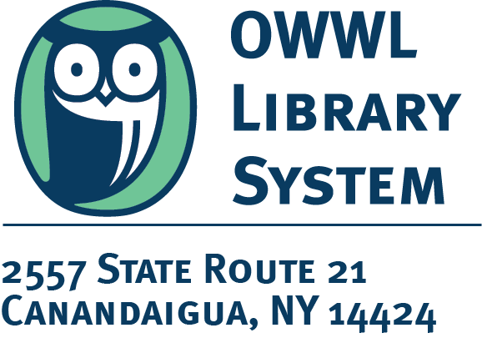
INTERLIBRARY LOAN ITEM

Title: The October Man
Author: Aaronovitch, Ben

Due date: 7/15/2024
NO RENEWALS

Please do not remove book strap
This item belongs to an institution other than OWWL and is subject to immediate recall.

Special circulation rules apply.

